**Shankh Bansal**

**AU22C1013**

**Sustainable Development Goal**

**Goal:1**

**End Poverty in all its forms everywhere**

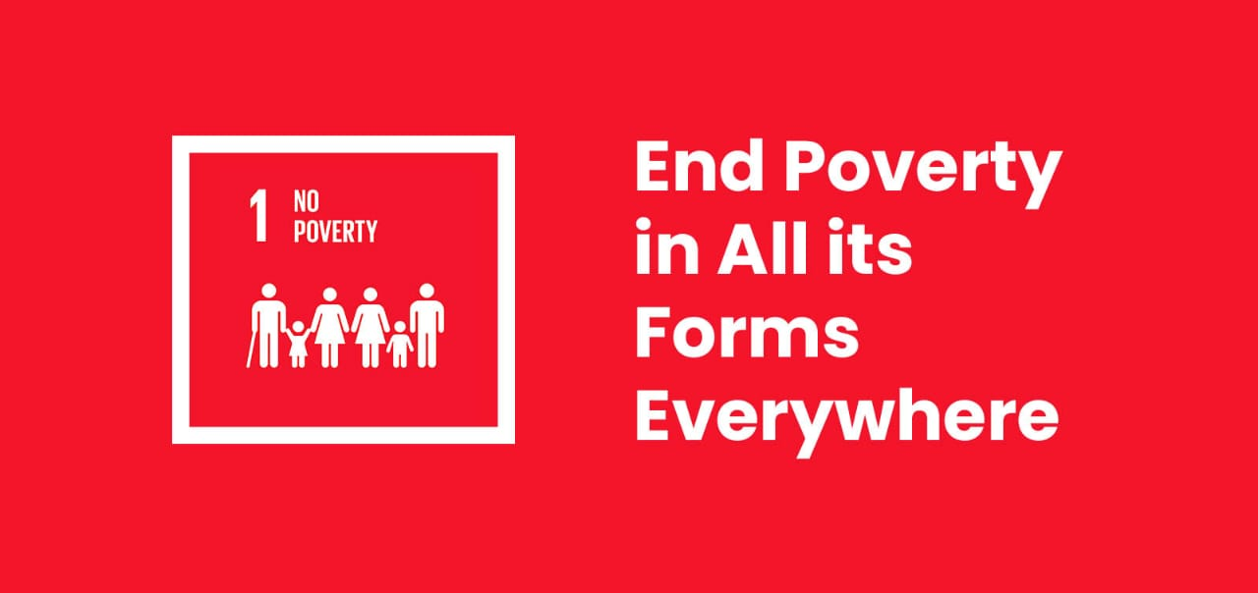

Sustainable Development Goals were adopted by the United Nations in 2015 as a universal call to action to end poverty, protect the planet, and ensure that by 2030 all people enjoy peace and prosperity. There are in all 17 SDG's currently which aim to balance social, economic and environmental sustainability. There are currently 193 countries working together with UN to achieve the target till 2030.

In this report we will be discussing about the first Sustainable Development Goal which is Poverty.

The first goal says "End poverty in all its forms everywhere". Eradicating extreme poverty for all people everywhere by 2030 is a pivotal goal of the 2030 Agenda for Sustainable Development. Global poverty is one of the most pressing problems that the world faces today. The poorest in the world are often undernourished, without access to basic services such as electricity and safe drinking water they have less access to education, and suffer from much poorer health. Poverty can be defined by a fixed value (absolute poverty) or by a value in relation to the rest of the population (relative poverty). Absolute poverty is measured by a minimum amount of money required to meet basic needs, known as a poverty line. A person is considered to be living in poverty if their income, expenditure or wealth falls below this line. In contrast, relative poverty is determined in relation to others: a person is in poverty if their income, expenditure or wealth is significantly below the average of the rest of the population. The international standard for measuring poverty is the extreme poverty line, a measure of absolute poverty with a threshold equivalent to US$1.90 per person per day. The extreme poverty threshold is considered as the minimum income or expenditure required to meet very basic needs. Following are the targets to be met currently:

1. By 2030, eradicate extreme poverty for all people everywhere, currently measured as people living on less than $1.25 a day

2.By 2030, reduce at least by half the proportion of men, women and children of all ages living in poverty in all its dimensions according to national definitions

3. Implement nationally appropriate social protection systems and measures for all, including floors, and by 2030 achieve substantial coverage of the poor and the vulnerable

4. By 2030, ensure that all men and women, in particular the poor and the vulnerable, have equal rights to economic resources, as well as access to basic services, ownership and control over land and other forms of property, inheritance, natural resources etc.

5. By 2030, build the resilience of the poor and those in vulnerable situations and reduce their exposure and vulnerability to climate-related extreme events and other economic, social and environmental shocks and disasters.

Before we discuss about the global scenario let's talk about our country India. India currently stands with 229 million multidimensional poor in absolute terms. This is by taking the 3 dimensions into consideration which are health, education and standard of living according to the report of 2022. After the advent of this particular in 2015 India lifted 415 million out of poverty in 15 years according to United Nations. The incidence of poverty fell from 36.6% in 2015-2016 to 21.2% in 2019-2021 in rural areas and from 9.0% to 5.5% in urban areas. India saw the impact of Covid-19 as well. Around 150–199 additional million people became poor due to COVID-19 crises, while those already poor were pushed deeper into poverty. Amongst the household type, casual labour households in the urban sector were the most impacted group, followed by self-employed and regular salaried. Additionally, the low-income states had the highest incidence of poverty, followed by the middle-income states due to the crises. The marked income inequity in the low-income states increased in post COVID-19 contractions. In the high-income states, the brunt of COVID-19 was seen in rural areas due to a large number of the rural population living near the poverty line and majorly because the area lacked employment and livelihood opportunities. Currently India Government has following plans which are being worked upon to eradicate poverty :

• Prime Minister Rozgar Yojana

• Rural Employment Generation Programme

• Swarnajayanti Gram Swarozgar Yojana Pradhan Mantri Gramodaya Yojana Antyodaya Anna Yojana

• National Food for Work Programme

• National Rural Employment Guarantee Act

Among which IRDP in India is among the world's most ambitious programs to alleviate rural poverty by providing income-generated assets to the poorest of the poor. Currently according to United Nations SDG target of reducing at least by half the proportion of men, women and children of all ages living in poverty in all its dimensions according to national definitions by 2030 is possible to achieve!!!

Now talking about the Global scenario the effects of the coronavirus disease 2019 (COVID-19) pandemic have reversed much of the progress made in reducing poverty, with global extreme poverty rising in 2020 for the first time since the Asian financial crisis of the late 1990s.The 2030 Agenda for Sustainable Development promises to leave no one behind and to reach those furthest behind first. Meeting this ambitious development agenda requires visionary policies for sustainable, inclusive, sustained and equitable economic growth, supported by full employment and decent work for all, social integration, declining inequality, rising productivity and a favourable environment. The World Bank estimated that around 8.5 percent of the world's population (685 million people) could be extremely poor by the end of 2022, and currently poverty is declining at a very slow rate of only 2 percent a year. Based on current projections, the global poverty rate is expected to be 7 per cent (around 600 million people) in 2030, missing the target of eradicating poverty. But there are constant efforts being made by each and every country to meet the set targets. There are currently 7 targets on which United Nations is working upon with all the countries globally.

The above report gives us a clear picture of the current scenario of Poverty globally and in India. It provides us with facts and figures which give us the hope and a wake-up call as well to eradicate this issue and achieve the goal collectively.

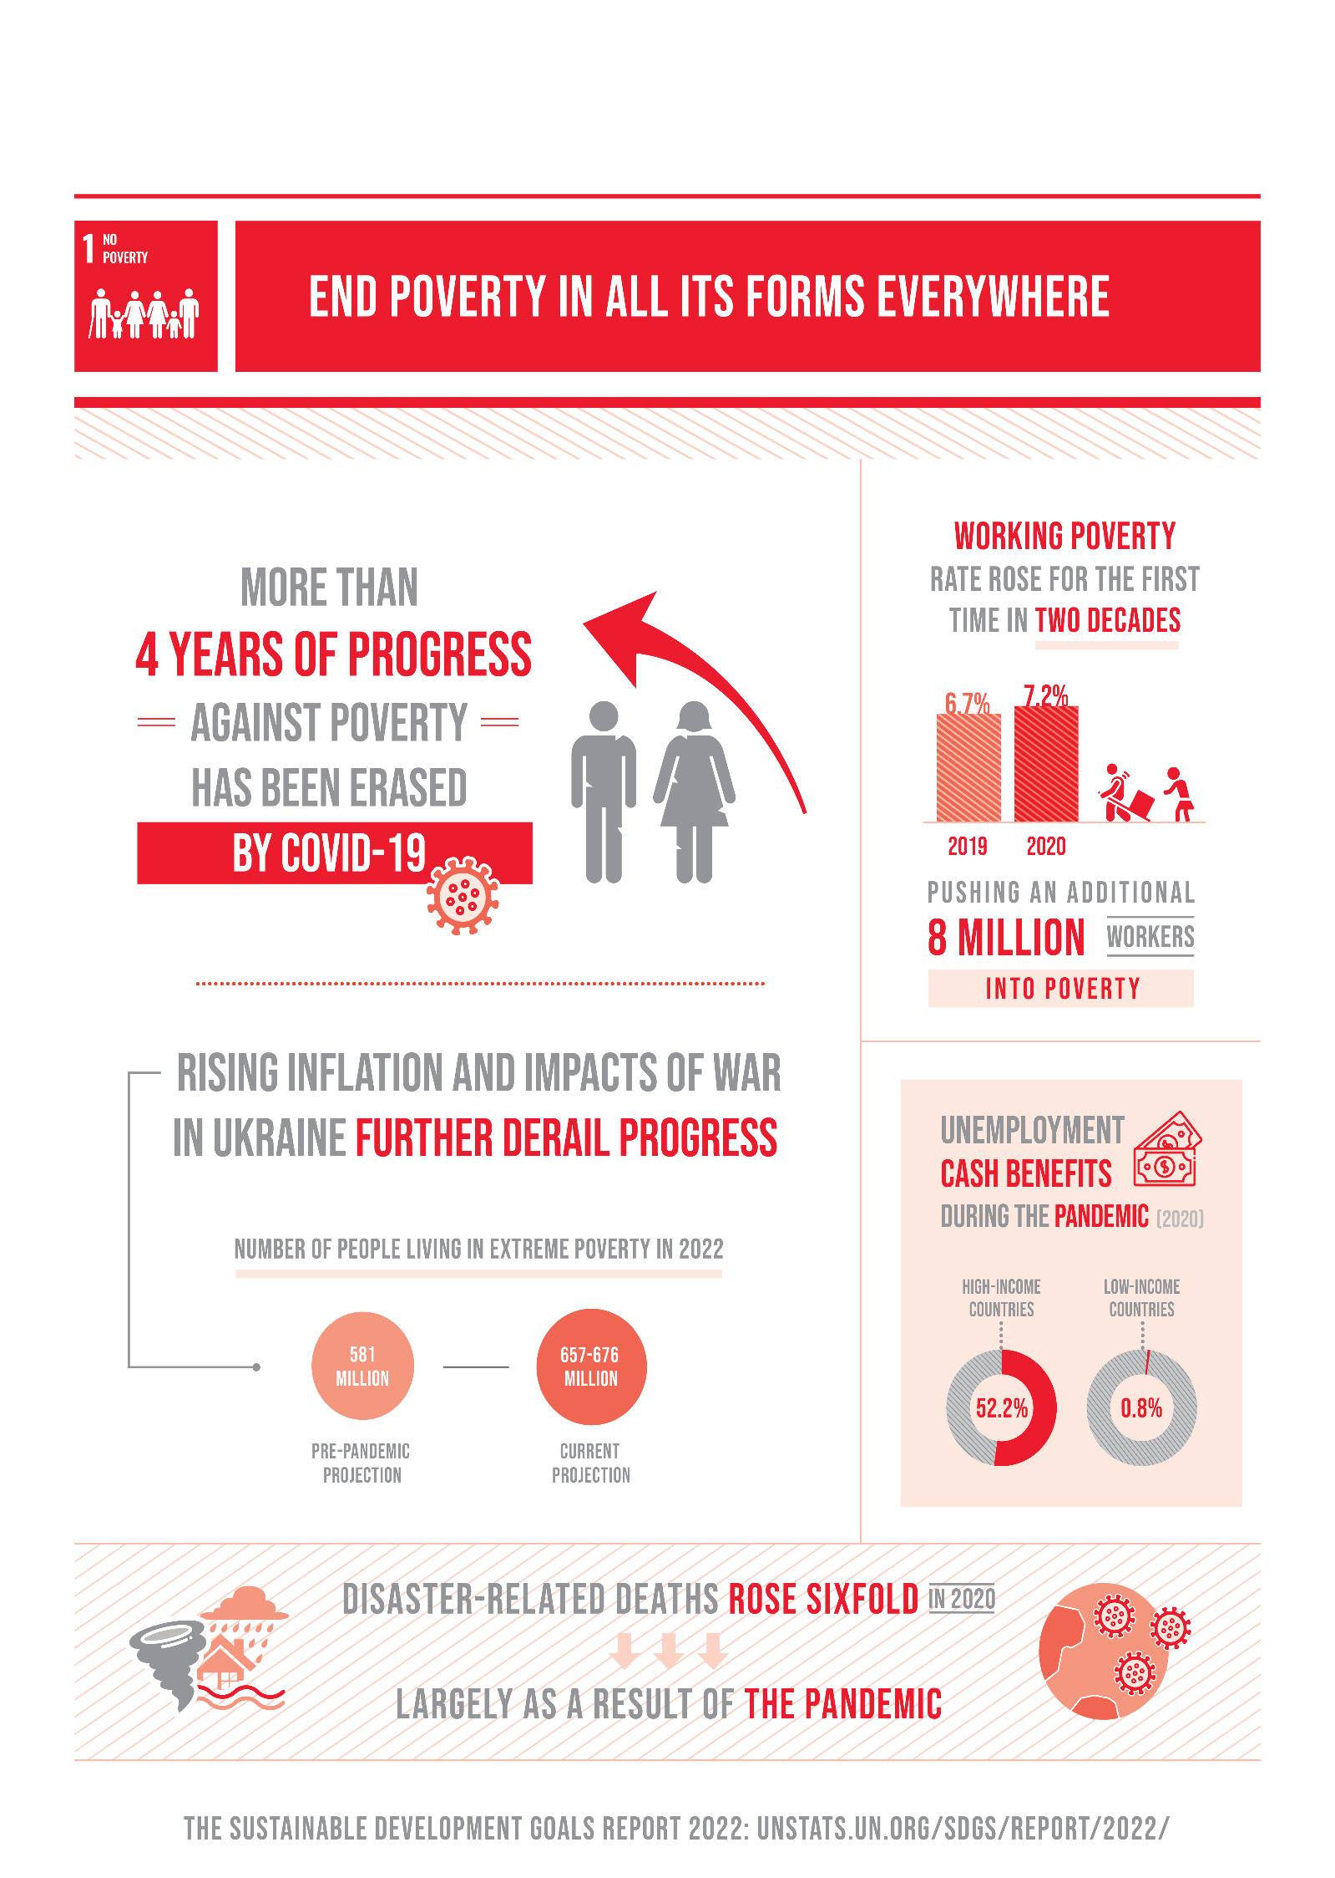

References:

<https://sdgs.un.org/goals/goal1>

<https://www.un.org/sustainabledevelopment/>

<https://en.unesco.org/sustainabledevelopmentgoals>

<https://www.niti.gov.in/sites/default/files/2021>